Java Memory Model & Memory Ordering
Purpose: Demonstrate why memory-ordering protection is required when threads communicate through shared variables, and explain how volatile establishes visibility and ordering guarantees.

1. Volatile Visibility Experiment
Two threads communicate through data and ready. The writer publishes the data and then signals readiness. The reader waits for the signal and reads the data.
Test: Run once with an ordinary boolean ready and again with volatile boolean ready.
static volatile boolean ready = false;
VS
static boolean ready = false;
Working version code
class VolatileExperiment {
static int data = 0;
static volatile boolean ready = false;
public static void main(String[] args) throws Exception {
Thread writer = new Thread(() -> {
data = 42;
ready = true;
});
Thread reader = new Thread(() -> {
while (!ready) {
Thread.onSpinWait();
}
System.out.println("Data = " + data);
});
writer.start();
reader.start();
writer.join();
reader.join();
}
}
Important: The non-volatile version is not required to print a wrong value every time. It may appear to work on a particular machine; the issue is that the JMM does not guarantee the required visibility/order.

2. Actual Evidence From the Experiment
The submitted screenshots show the experiment being compiled and executed repeatedly. Both the non-volatile and volatile versions produced Data = 42 in the observed runs.

Evidence A — without volatile
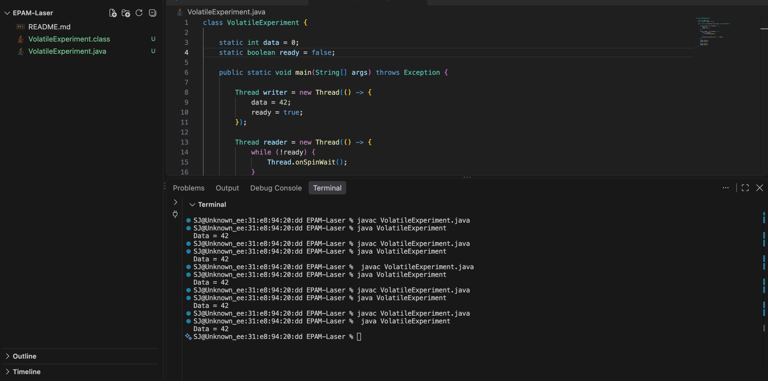

Evidence B — with volatile
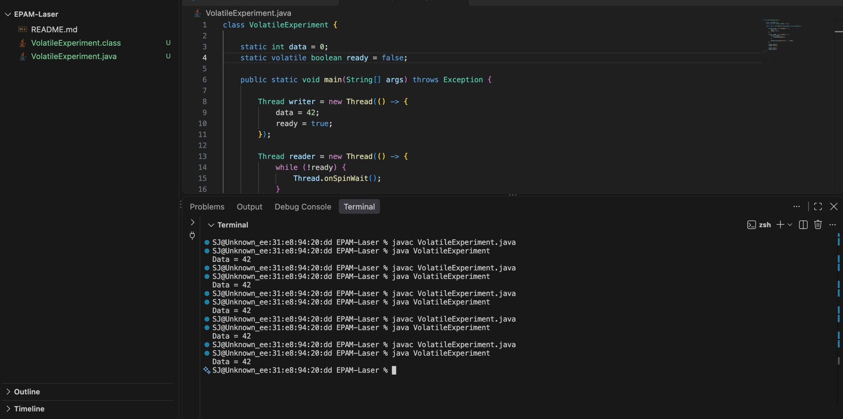
Observation: Both versions produced Data = 42 during the observed runs. However, the non-volatile version has no JMM guarantee of visibility because the shared ready variable is not synchronized. The volatile version establishes the required visibility and ordering through the happens-before relationship.

Evidence summary
Run | Without volatile | With volatile
1 | Data = 42 | Data = 42
2 | Data = 42 | Data = 42
3 | Data = 42 | Data = 42
4 | Data = 42 | Data = 42
5 | Data = 42 | Data = 42
Note: The screenshots establish observed behavior, not a proof that the non-volatile program is safe. The proof comes from the JMM rules.

3. Environment Details
Parameter | Details
CPU | Apple M1
Operating System | macOS 26.6.2
Build Version | 25G83
JDK | OpenJDK 21.0.12.1
JDK Distribution | Homebrew
JVM | OpenJDK 64-Bit Server VM
Threads | 2
Experiment Output | Data = 42
Experiment Type | Volatile visibility / memory-ordering experiment

4. Happens-Before in This Experiment
The volatile write to ready happens-before a subsequent volatile read of ready. Consequently, the preceding write data = 42 is guaranteed to be visible to the reader after it observes ready == true.
┌──────────────────────┐
│ WRITER THREAD │
└──────────┬───────────┘
│
▼
data = 42
│
▼
ready = true (volatile write)
│
│
│ HAPPENS-BEFORE
▼
(volatile read)
read ready
│
▼
ready == true
│
▼
read data
│
▼
data == 42 ✓

5. Why Memory Ordering Protection Is Required
Without Synchronization | With volatile
Writer: data = 42<br>ready = true | Writer: data = 42<br>ready = true (volatile)
Reader: while (!ready) {}<br>read data | Reader: while (!ready) {}<br>read data
❌ No happens-before relationship | ✅ Volatile write → read establishes happens-before
❌ No guaranteed visibility/order | ✅ Previous data = 42 is guaranteed visible
May appear to work, but not guaranteed by JMM | Safe for this publication/visibility pattern

6. Conclusion
The experiment shows that observed output is not the same as a memory-model guarantee. Both versions produced Data = 42 in the captured runs, but only the volatile version provides the required visibility and ordering relationship for this publication pattern. This is the central reason the JMM, happens-before, and memory-ordering mechanisms matter in concurrent Java programs.

7. References
- Oracle — Java Language Specification, Chapter 17: Threads and Locks — JMM, happens-before, volatile, synchronization. Oracle JLS
- Vlad Zuev — Java Multithreading, Lesson 59: Java Memory Model — JMM, reordering, memory barriers, volatile. YouTube — Vlad Zuev
- EverythingAboutJava — Happens-Before Relationship in Java — Happens-before, visibility, volatile, synchronization. YouTube — EverythingAboutJava

